Perth & Kinross Employability Project
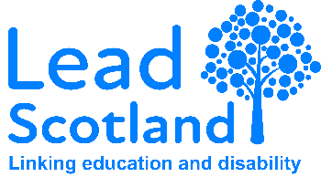
Learning with Lead Scotland
At Lead Scotland, we work with you to find a way that you can learn. Our services are free to all learners, and can be delivered in the community or at home, and in group sessions or on a one-to-one basis. We have a person-centred approach, which means we listen to what you want. Our Learning Coordinator will talk to you about what, how and when you want to learn and will support you to start learning in a way that suits you.
To be eligible for this project, you must:
- Be aged between 16-67 years old,
- No longer be enrolled at school,
- Reside in Perth & Kinross,
- Have the right to work in the UK,
- Consider yourself disabled, an unpaid carer or have another barrier to learning.
We are here for you if you need help improving your confidence, starting to prepare for employment or finding a job. What can you do with our learning coordinator?
- Formal, accredited qualifications
  - Adult Achievement Award
  - SQA Qualifications
    - Literacy
    - Numeracy
    - Steps to Work
    - Cyber Security
- Informal learning opportunities, including digital skills
- Travel training
- Accessing volunteering opportunities
- CV and interview preparation
- Searching for jobs
The Perth & Kinross Employability project gives people dedicated support to progress in their ability to engage and access the world of work, education, volunteering, or skills development. The project is suitable for those who are starting out on their journey towards employability and supports those who are at pre-stage 1, stage 1 or stage 2 of the employability pipeline. We support learners to work on their self-defined goals and achieve their potential by developing key core skills and improving qualification profiles. Learners will also improve their transferable skills for the world of work including regular attendance, commitment, communication, listening skills and team working. This project has no entry requirements. Your Learning Coordinator will work with you to tailor an action plan to suit your goals
Your contact at Lead Scotland:
Katie Tolland – Perth & Kinross Learning Coordinator
07768917492
ktolland@lead.org.uk

